TASK 1

Three phase motor operated with full voltage magnetic starter controlled by stop & start push button station

Power Circuit

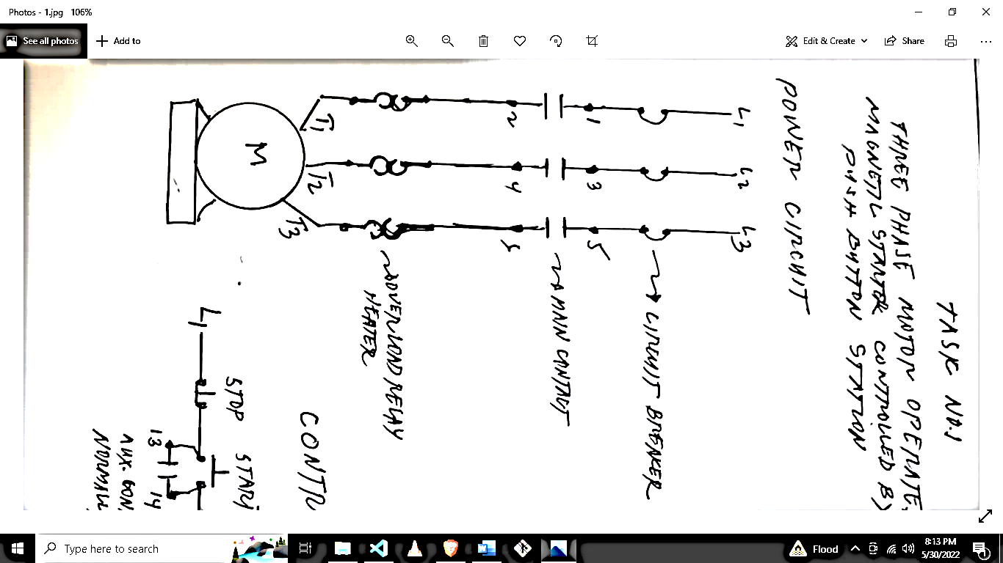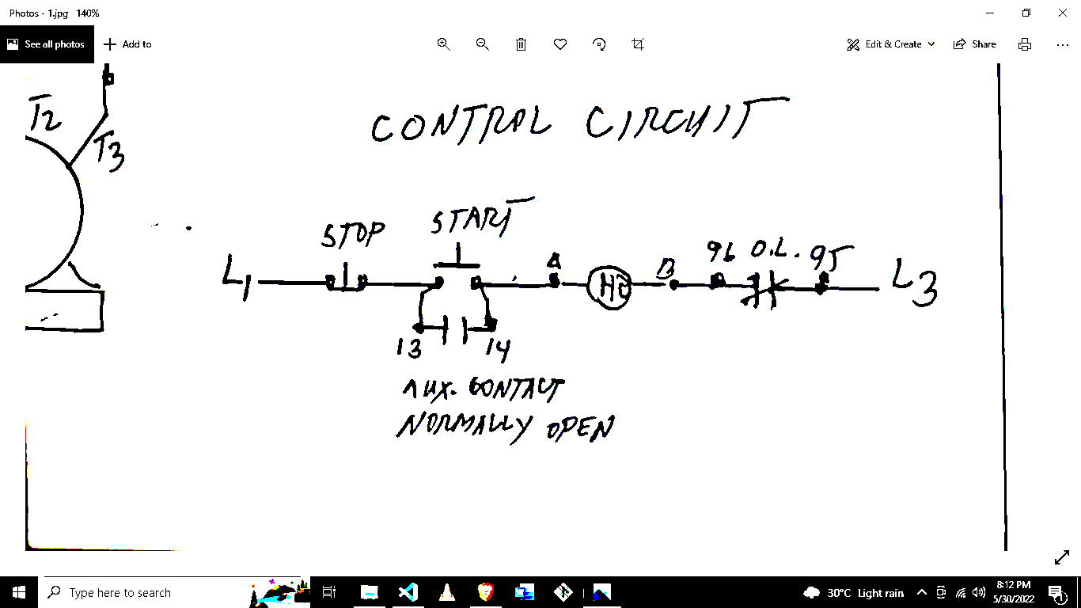

Overload Relay Heater

Main Contact

Circuit Breaker

Auxiliary Contact Normal Open

Control Circuit